Homework Week 7 Due Next Wednesday 10/09/2014

Name:________________ Mark: / 30+8

1. Label the sides of the following triangles (using O, A, H). [ 2 marks]
a.
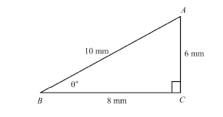
b.
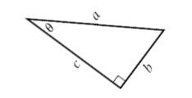

2. What are sin θ, cos θ and tan θ for each of the above triangles? [6 marks]
a.
sin θ= cos θ= tan θ=

b.
sin θ= cos θ= tan θ=

3. For each right angled triangle, write down the correct trigonometric equation and solve for the unknown sides, x. [12 marks]

a.
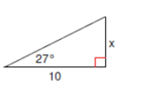

b.
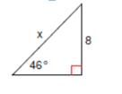

c.
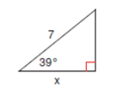

4. ABH is a right triangle with a right angle at H. Also, BHC is a right angled triangle at H. Angle A is 39º; BH is 11 cm and AC is 19 cm. What is x, the length of BC? (correct to 2 decimal places). [5 marks]
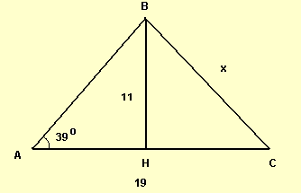

5. ABC is a right triangle with a right angle at A. Find x, the length of DC. [5 marks]

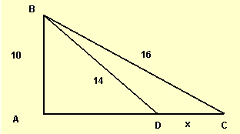

Bonus
6. Use the right angled triangle from Question 1a. Instead of using angle B as the reference angle, use angle A as the reference angle θ (which is the angle adjacent to side AC). What is the sum of angle A and angle B (Remember they are complementary angles)? Calculate sin θ, cos θ and tan θ. Hence find the relationship between sin A and cos B and the relationship between tan A and tan B. (Hints: 1) You need to redraw the triangle with A, B, and C correctly labelled. 2) You can multiply tan A and tan B to find the relationship. 3) A, B and C are referred to the three angles of the triangle in this case.) [Total marks:8]
Step 1: Redraw the right angled triangle. [1 mark]

Step 2: What is the sum of angle A and angle B. Find sin A, cos A and tan A. [4 marks]

Step 3: Compare your sin A with cos B, sin B with cos A and tan A with tan B. Note: You have already found the sin B, cos B and tan B in Question 2 (a). [3 marks]

