Year 9 Maths Name: _____________
Total: / 22

%
Trigonometry – Homework 8

Due date: Wednesday, 17th September (Week 9)
SOH CAH TOA

- Find the size of each of the following unknown angles, correct to one decimal place:
[6 marks]

- Multiple choice:
A ski slope falls a vertical height of 550 m for a distance of 1750 m travelled down the ski hill. What is the measure of angle θ, to the nearest degree?
[1 mark]
A: 17° B: 18° C: 72° D: 73°

- A ladder leans up against a brick wall, making an angle of 62◦ with the ground. The foot of the ladder is 3 meters from the base of the wall. Use the correct trig ratios to find out the length of the ladder and how far up the wall the ladder will reach (correct to 2 decimal places)? Check your work by using Pythagoras (show your checking process). [5 marks]
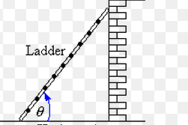
x
3 m
62º

- a) If we used the same ladder from Question 3 (the one with the same length as in Q3) and tried to place the ladder 7 meters away from the base of the wall, what is the angle made between the ladder and the ground and how far up the wall could the ladder reach? Explain if your answer makes sense. [4 marks]

- On top of a building, you look down and measure the angles as 17° and 13° as shown in the diagram. This tower is situated on top of another building 350 metres away,
measured horizontally. To the nearest metre, what is the height of this tower? [5 marks]
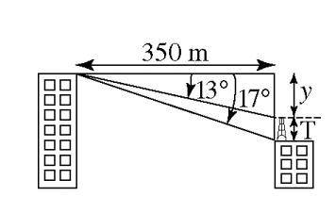

- Multiple choice: The value of θ, to the nearest degree, is:
[1 mark]
A: 65° B: 57°

C: 59° D: 69°

