Trigonometry – Final Test Name: _______________
SOH CAH TOA
Total: / 45

%

Show all of your working for full marks.
Time limit: 30 minutes

- Label the hypotenuse, adjacent, opposite and the reference angle θ (in the first triangle), in the following right-angled triangles. [6 marks]
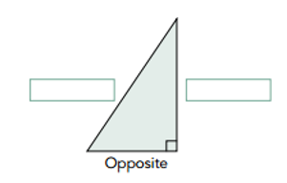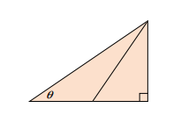

- From the diagram, write a trigonometric ratio for each of the following: [5 marks]

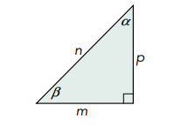
  - sin α

  - tan β

  - cos β

  - What do you notice about the values of sin α and cos β?

  - If sin 72º = cos θ, what is θ?

- The hypotenuse of the right-angled triangle (pictured below) is 16.8 cm. It is known that cos α =$\frac{3}{7}$ ; find the length of the adjacent side. [4 marks]

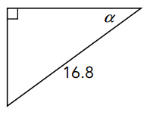

- The right-angled triangle (pictured below) has a reference angle of 32º and the hypotenuse is 70 cm. Use the correct trigonometric ratio to solve for the unknown adjacent side. [3 marks]

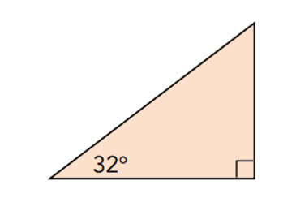
z cm
70 cm

- The following right-angled triangle has a tanα ratio of 0.58. Suppose that the adjacent was instead 12.9 cm long and the opposite was 7.5 cm long, but the angle (α) remains the same. [3marks]

  - What would you expect the tanα ratio to be in the new triangle?

  - Explain, with reasons, why this would be.

- A 9m slide at a playground makes an angle of 28° with the ground. How high above the ground, correct to one decimal place, is the top of the slide? (Hint: Draw a diagram.) [4 marks]

- A 15.6 m flagpole is attached to a guy rope that makes an angle of 53° with the ground. What is the distance from the guy rope to the base of the flagpole, correct to one decimal place? [4 marks]
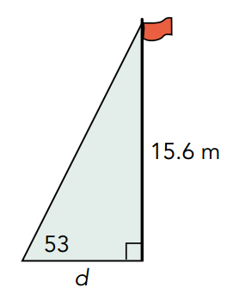

- A tent has a vertical pole 1.8 m tall. How long is the guy rope attached to the tent pole if the angle between the ground and the rope is 40º? (Hint: Draw a diagram.) [5 marks]

- Find the two unknown angles, α and θ in the following diagrams. Give your answers correct to one decimal place. [6 marks]
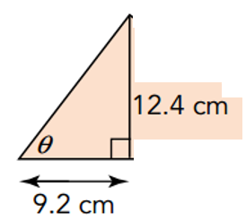

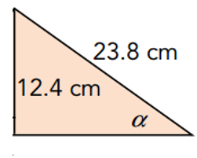

- A ladder is 5 m long and when placed against the wall it reaches 2.6 m up the wall. Calculate the angle formed between the ladder and the ground. (Hint: Sketch a diagram) [5 marks]

