Trigonometry Name: _______________
SOH CAH TOA
Total: / 40

%

- Label the hypotenuse, adjacent, opposite and the reference angle θ (in the second triangle), in the following right-angled triangles. [6 marks]
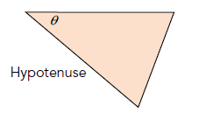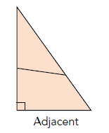
Hint: You may add a construction line to the first triangle

- From the diagram, write a trigonometric ratio for each of the following: [5 marks]

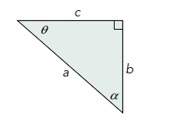
  - tan α

  - tan θ

  - cos α

  - What do you notice about the values of tan α and tan θ? (Hint: Multiply them together)

  - If ten βº = b, what is tan (90-β)º?

- The hypotenuse of the right-angled triangle (pictured below) is 78.3 cm. It is known that sin α =$\frac{5}{6}$ ; find the length of the opposite side. [4 marks]

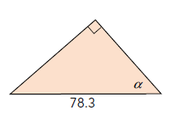
x cm

- The right-angled triangle (pictured below) has a reference angle of 72º and the opposite is 19.5 cm. Use the correct trigonometric ratio to solve for the unknown adjacent side. [3 marks]

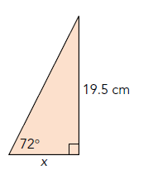

- The following right-angled triangle has a cosα ratio of 0.45. Suppose that the adjacent was instead 3.75 cm long and the hypotenuse was 8.4 cm long, but the angle (α) remains the same. [3marks]

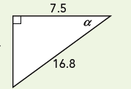

  - What would you expect the cosα ratio to be in the new triangle?

  - Explain, with reasons, why this would be.

- A swimmer, 0.32 km from the base of a cliff, looks up and waves to his friend who is at the top of the cliff. The angle when he looks at the top of the cliff is 20º, Find the height of the cliff, correct to one decimal place. (Hint: Draw a diagram.) [4 marks]

- There is a mast that is 70 metres high. A wire goes to the top of the mast at an angle of 68°( as shown below). How long is the wire? [4 marks]
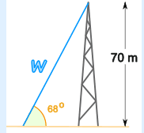

- Find the two unknown angles, θ in the following diagrams. Give your answers correct to one decimal place. [6 marks]
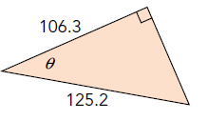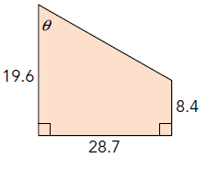

- David is 1.85 metres tall and casts a shadow 2.43 metres long. Find the angle that the sun makes with the ground. (Hint: Draw a diagram.) [5 marks]

