Week 7 Homework Sheet Due Next Wednesday (10/09/2014)
Total Marks: /52 Name:________________

1. If a variable can be measured in fractions of units, it is a ________ variable. [1 mark]
a. discrete
b. continuous
Your answer: ______

2. Are the following sets of data continuous or discrete? Write C for continuous and D for discrete. [4 marks]

a. Weight of a rat in grams Your answer: _________
b. Number of heart attacks Your answer: _________
c. The number of students in a class Your answer: _________
d. The yearly temperature in Melbourne. Your answer: _________

3. Are the following variables nominal or ordinal? Write N for nominal and O for ordinal. [4 marks]
a. Hotel service satisfaction (eg, poor, average, good, etc.) Your answer:_________
b. The kinds of fruits sold in Woolworths Your answer:_________
c. The colour of dogs Your answer:_________
d. How well steak is cooked. Your answer:_________

4. A number of students were asked how many siblings they have and the column graph is shown below.
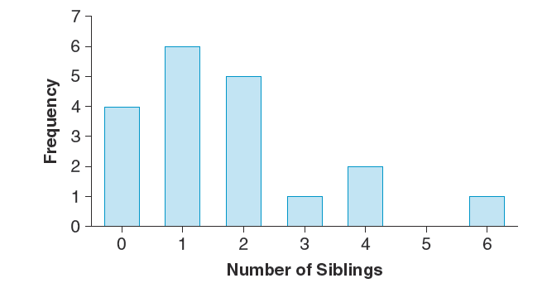
a. Fill in the frequency columns below. [8 marks]
The number of siblings | Frequency | Percentage frequency
0
1
2
3
4
5
6
Total

b. How many students were surveyed? [1 marks]

c. What is the most common number of siblings students have? [1 mark]

d. What percentage of students have 2 or 4 siblings (Show your work)? [4 marks]

e. Fill in the last column with percentage frequency. [8 marks]
h. How many siblings in total do these students have? [2 marks]
5. The speed of vehicles travelling along a section of highway has been recorded in the table below.
Speed interval (km/hour) | Frequency | Percentage Frequency
60- | 40
70- | 65
80- | 120
90- | 100
100- | 80
110- | 16
120- | 12
130- | 8
Total

- What is this table called? How many vehicles were included in this survey? [2 marks]

- Fill in the percentage frequency column of the table. [9 marks]

- Construct a histogram from the table. Please draw on the grid paper provided and attach it to the end of the homework sheet. Is it symmetrical, positively skewed or negatively skewed? [5 marks]

- If the drivers travelling at 110km/h or more were fined $180 each, what amount would be collected in fines? (show your work) [3 marks]

For Question 5(c)

