03/09/2014 9MA Lesson Plan

Lead in and Revision
A brief self-introduction, roll and why we need to learn maths and the method
The aim today is to learn how to use trigonometry to find the three sides of a right angled triangle.
- What is the sum of all the three inferior angles of a triangle?
- What is a right angled triangle? (Ask a student to answer and draw it on the board)
- If one angle is 90, what is the sum of the other two?
Review how to label opposite, adjacent and hypotenuse sides of a right angled triangle for a given reference angle.
Important points:
- The hypotenuse is always the longest side of a right angled triangle
- The reference angle cannot be 90 degrees.
- The adjacent and opposite sides depend on the choice of the reference angle.
- Sin, cos and tangent.
- Pythagoras ( develop the ability to think mathematically. Link different topics together)
- The complementary angles
[15min]

Exercises
Textbook page 408 Change the question to find all the sides and angles of the right angled triangles. Q1(a) (b) (c), Q2 (a) (b) (c) [Do one example on the board and ask students to do each on the board .]
1) we can use different ways to solve problems. 2) What are the differences between q1 and q2 and what are the similarities? 3) The trigonometric relationship between complementary angles??(Maybe beyond the scope of the course) [30min]

Why we need to study trigonometry?
See ppt. [15 min]

Exercises
See notebook. Backup plan page 409 question 4,5,6,7 (20 min)

Summary and video

http://www.analyzemath.com/high_school_math/grade_10/trigonometry.html
useful resources
http://www.pearson.com.au/media/637085/austsignpostmathsnsw_sb9_5.1-3_13.pdf

http://malini-math.blogspot.com.au/2011/08/applications-of-trigonometry-in-real.html
real world
http://www.youtube.com/watch?v=N2-y-y8BLRs
trig 4 min
http://www.youtube.com/watch?v=Q2bF26372gk
maths every where 4 min

http://www.skwirk.com/p-c_s-12_u-95_t-230_c-770/angles-of-elevation-and-depression/nsw/angles-of-elevation-and-depression/trigonometry/applications
Suppose that you are looking at an object in the distance.
If the object is above you, then the angle of elevation is the angle your eyes look up.
If the object is below you, the angle of depression is the angle your eyes look down.
Angles of elevation and depression are measured from the horizontal.
It is common mistake not to measure the angle of depression from the horizontal.
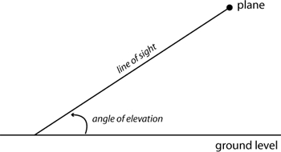
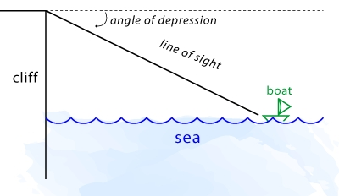
Using the angle of depression or elevation to an object, and knowing how far away the object is, enables us to find the height of the object using trigonometry.
The advantage of doing this is that it is very difficult to measure the height of a mountain or the depth of a canyon directly; it is much easier to measure how far away it is (horizontal distance) and to measure the angle of elevation or depression.

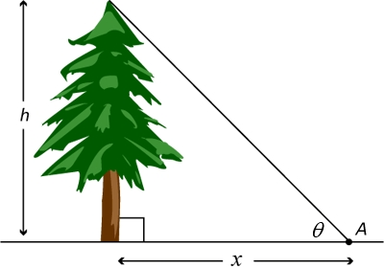
1. Mick looks out from his executive office window after a big luSuppose that we want to find the height of this tree.
We mark point A and measure how far it is from the base of the tree.
Then we measure the angle of elevation from A to the top of the tree.
Now,
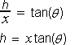
we have measured x and , so we can calculate tan() and thus we can find h, which is the height of the tree.
Mick looks out from his executive office window after a big lunch, and sees his Mercedes parked 500m down the street. If the angle of depression to the car is 56º, how far up the building is Mick's office?nch, and sees his Mercedes parked 500m down the street. If the angle of depression to the car is 56º, how far up the building is Mick's office?

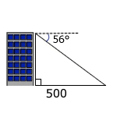

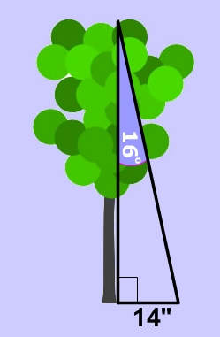What is the height of the tree on the left?
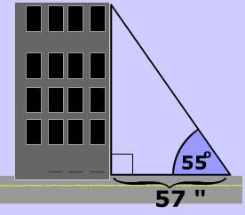At 57" from the base of a building you need to look up at 55° to see the top of a building. What is the height of the building?

